**Task 1**

**Problem Statement:**

Like most users, Chef didn’t know that he could add problems to a personal to-do list by clicking on the magic **'+'** symbol on the top-right of each problem page. But once he found out about it, he went crazy and added loads of problems to his [to-do](https://www.codechef.com/practice/todo) list without looking at their difficulty rating.

Chef is a beginner and should ideally try and solve only problems with difficulty rating strictly less than 10001000. Given a list of difficulty ratings for problems in the Chef’s to-do list, please help him identify how many of those problems Chef should **remove** from his to-do list, so that he is only left with problems of difficulty rating less than 10001000.

**Input Format**

* The first line of input will contain a single integer T*T*, the number of test cases. Then the testcases follow.
* Each testcase consists of 2 lines of input.
* The first line of input of each test case contains a single integer, N*N*, which is the total number of problems that the Chef has added to his to-do list.
* The second line of input of each test case contains N*N* space-separated integers D_1, D_2, \ldots, D_N*D*1​,*D*2​,…,*DN*​, which are the difficulty ratings for each problem in the to-do list.

**Output Format**

For each test case, output in a single line the number of problems that Chef will have to remove so that all remaining problems have a difficulty rating strictly less than 10001000.

**Solution:**

x=int(input())

for i in range (0,x):

N=int(input())

l=list(map(int,input().split()))[:N]

flag=0

for k in l:

if (k>=1000):

flag+=1

print(flag)

**Result:**

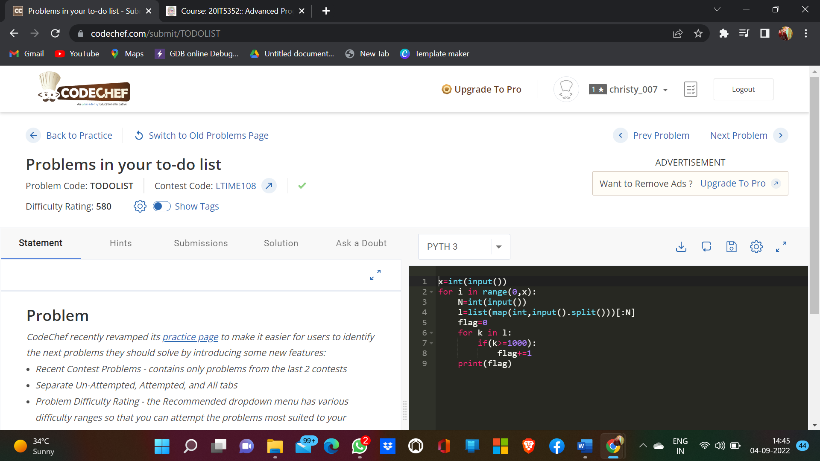

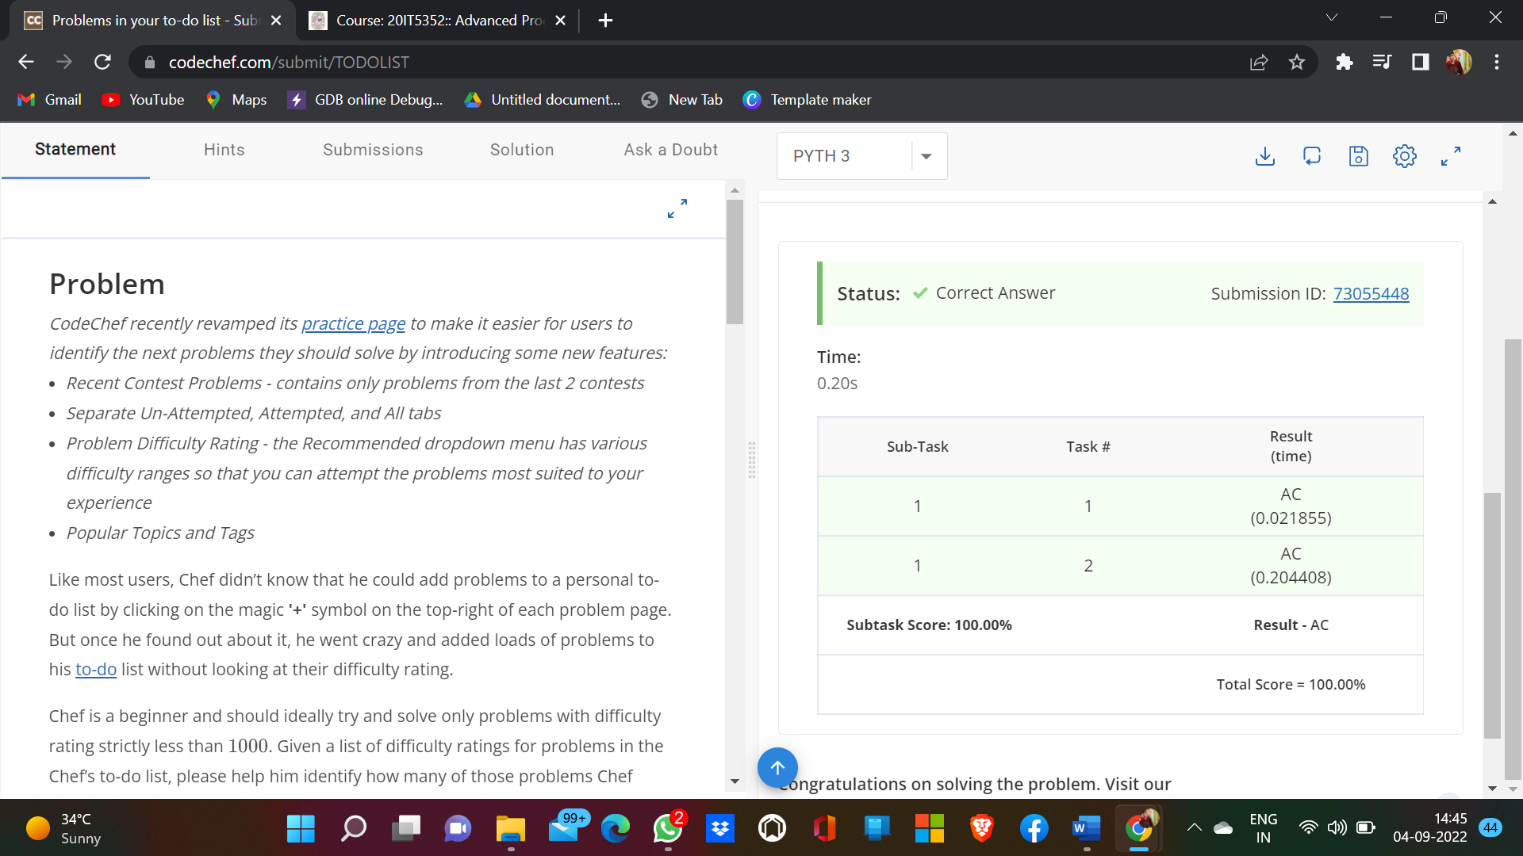

**Observation:**

Program Executed Successfully.